**Telecom Churn Analysis**

**Ravinder Kumar**

**Data science trainees,**

**AlmaBetter, Bangalore**

**Abstract:**

In the telecom industry, customers are able to choose from multiple service providers and actively switch from one operator to another. The switching of customers from a particular company to other is known as **Customer Churn**.

## We are provided with The Orange Telecom's Churn Dataset, consists of cleaned customer activity data (features), along with a churn label specifying whether a customer cancelled the subscription.

## Our analysis can help to identifying the factors that are responsible for Customer churn and also helpful for determining the way to reduce customer churn.

**1. Problem Statement**

## The Data is provided by **Orange S.A., formerly** France Télécom S.A. It is a multinational Telecom Company. It provide data in the sake of getting some ways to ensure customer retention.

In the telecom industry, customers are able to choose from multiple service providers and actively switch from one operator to another. **In this highly competitive market, the telecommunications industry experiences an average of 15-25% annual churn rate.** Given the fact that it costs 5-10 times more to acquire a new customer than to retain an existing one, customer retention has now become even more important than customer acquisition.

## For many incumbent operators, retaining high profitable customers is the number one business goal. **To reduce customer churn, telecom companies need to predict key factors responsible for customer churn**

**2. Introduction**

In the telecom industry, customers are able to choose from multiple service providers and actively switch from one operator to another. The switching of customers from a particular company to other is known as Customer Churn.

## In this project we do some EDA on provided data. Our goal is to finding the key factors that are responsible for customer churn and also making some recommendation to ensure customer churn.

## **3. Types of Plans**

## The Plans are mainly categories into two types:-

## Base Plans

## Additional Plans

## **2. Additional Plans**

## There are two additional plans

## **International Plan**

## International Plan gives facility of receiving and sending or receiving Data from the other telecom service provider when you are traveling outside the geographical location of the telecom service area.

## **Voice Mail Plan**

Voice mail plan give the facility of describes a network system that enables unanswered phone calls to be diverted to a personal answering service.

## **4. Steps involved:**

## **Data Exploration**

## After loading dataset we perform this method to make the dataset ready for EDA.

## **This process includes the following tasks:**

1. **Examine the Size of Dataset:**

In this step we figure out the number of Observations and Variables

1. **Determine the NULL Values:**

This step involves the treatment of Null Values. But our Dataset have no Null Values.

1. **Examine the Dataset:**

This step involves of getting description of the data in the dataset. The description contains these information for each numerical columns. This step also contains the examination of frequency distribution.

1. **Identify the Outliers:**

In our dataset I have some columns that have some outliers. An outliers are a data points that are differs significantly from other observations. Therefore in this step we identify the outliers.

* **Finding the Correlation Between the Columns**

I find the relation between different features. We find the dependent features. After identifying we drop those features because dependent features doesn’t contributes any additional information.

* **Examine the relation between Churn and Categorical Features**

I examine the churn rate in Categorical features (International Plan, Voice Call Plan). We examine the churn rate between those customers who buy International Plan & Voice plan and who doesn’t buy these plans separately.

* **Examine the relation between Customer Service call and Churn Feature**

It is very important that Customer service call should work on up to the mark but I found that Customer Service call doesn’t work up to the mark, the churn rate was increased rapidly after four calls.

## **Numerical Variables and Churn relation Visualization**

## We visualize how the churn rate increase when the different minutes variables are increased

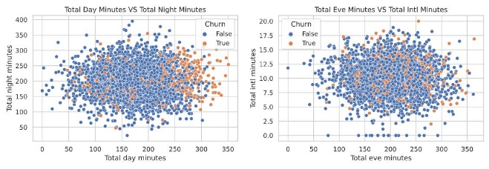

* **Examine the Churn ratio of each State**

At the end I examine the churn ratio in each state. I also find the number of loyal and unloyal customer in each states

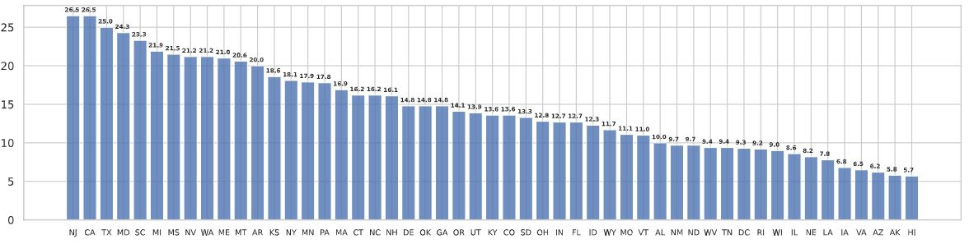

**5. Conclusion**

Finally our EDA is finish. At the end I found some key factors that are responsible for Customer churn.

* Most of the Customers who disconnect their connections are very active user of communication service.
* The rate of Churn more in those customers that enable International Plan as compare to those customers that doesn’t enable the International  Plan.
* It seems that the rate of churn in those customers that doesn’t enable anyVoice mail plan are more.
* Most of the customers problems are solved in 2-3 calls but after 2-3 calls the customers that still having any problem they seems to unsubscribe their plans.

**After considering all the key factors I come up with some Recommendations:**

* Since most of the customer churn come up by a communication service,

So I think company will need to undertake additional economic analysis

To find out whether such measures

Would be beneficial.

* There is also required some Improvement in international service and also require some new low budget Voice mail and International plans.
* It seems that the some of the customer’s queries are not solved even after 4 customer service calls. So, highly recommend you to improve your customer service calls.

.